**Macintosh HD:Users:csnay:Desktop:Logos:snite logo black.pdf**

## Media Contact

Gina Costa

Phone: 574-631-4720

Fax: 574-631-8501

PO Box 368

University of Notre Dame

Notre Dame, IN 46556

gcosta@nd.edu

*University of* NOTRE DAME

## FOR IMMEDIATE RELEASE

***SEIZING BEAUTY: PHOTOGRAPHS BY PAULETTE TAVORMINA***

**August 21- November 27, 2016**

**Snite Museum of Art**

**University of Notre Dame**

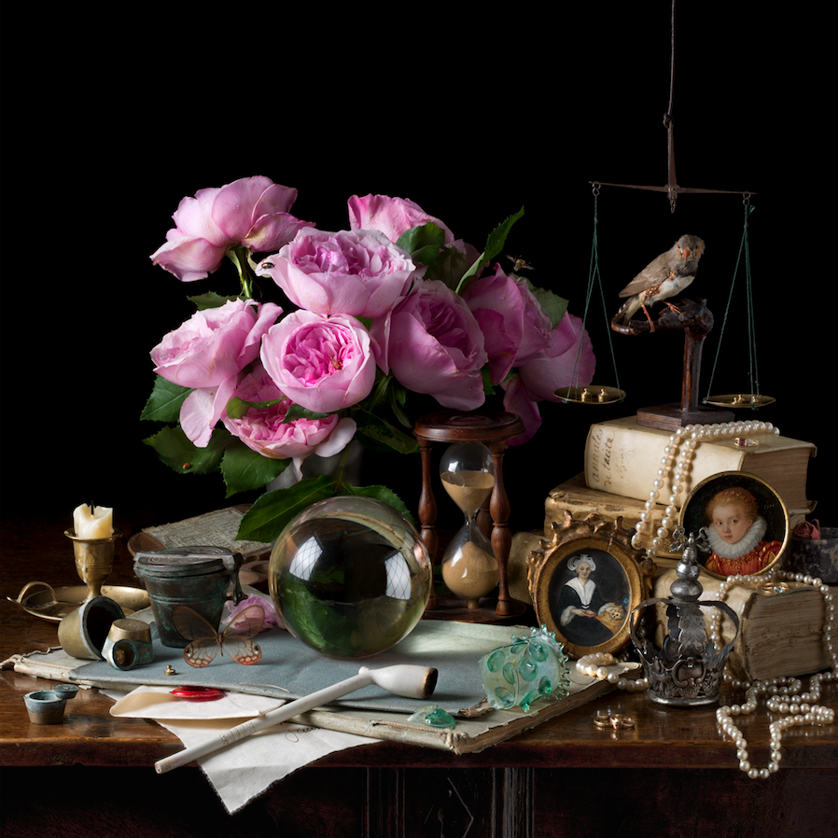

**NOTRE DAME, IN—July 14, 2016**

*Seizing Beauty* is the first museum exhibition of works by Paulette Tavormina, a New York creative photographer celebrated for her reinterpretation still life paintings of the Old Masters. The representation of commonplace objects had its origins in ancient Greek and Roman painting. But it was in the Low Countries, at the end of the sixteenth century, that still life emerged as a genre and professional specialization.

The English term *still life* derives from the Dutch *stilleven*. When the nexus of European commerce shifted to the Netherlands in the fifteenth century, the fine arts were also affected by the Protestant Reformation. A growing merchant class replaced the Church as leading patrons of the arts. Among the paintings that these burghers acquired to decorate their homes, were enchanting and affirming still lifes. The painters drew upon refined traditions of representation and illusion techniques from illuminated manuscripts and panel painting. By 1600 oil paintings of fruit and flowers had become a craze. The fad was concurrent with the Dutch mania for horticulture, and like the most exotic tulips, the paintings reflected the prosperity and grace of their owner. The artists usually chose the subject and created the arrangement of these images, which were sold in studios, shops, or open markets. They often designed their paintings to carry hidden messages, based upon the folk or religious symbology of the flowers or fruits. During the seventeenth century, the popularity still life painting spread from Holland to Flanders and Germany, and also to Spain and France.

Paulette Tavormina first carefully considered European still life paintings during the 1980s, when a fellow artist in Santa Fe introduced her to the work of women masters of still life in the seventeenth-century, like Giovanna Garzoni and Maria Sibylla Merian. She had studied photography in New York and Santa Fe, and had begun to photograph historic Native American pottery and jewelry. Her sensitive and detailed images led to commercial projects for the illustration of a popular series of Southwestern cookbooks. Soon her eye and skill led to work as a food stylist and prop specialist for feature films in Hollywood.

To explore aesthetic goals to match her technical skills, Tavormina made an extended visit to Sicily, seeking out her ancestral roots and living relations. She returned to New York City, and began working at Sotheby’s, the international fine arts auction house. She photographed works of art for auction catalogues, advertising, and scholarly study. Her work provided an extraordinary opportunity to observe and study European still life painting first hand. She learned its subtlety, complexity, and life enhancing power. Soon, in her own apartment studio, Tavormina experimented with photographic images inspired by the Old Masters. She recreated still-life arrangements inspired by artists such as Garzoni, and Merian, as well as Francesco de Zurbarán, Willem Claesz. Heda, and many others. Tavormina gathers her subjects, and arranges her compositions, exactly as her forebears. Her photographs reveal a practical knowledge of composition, color, form and illumination, comparable to their own. Aside from her fine art work, Tavormina has continued to produce lush images for cookbooks, and historicizing photographs to illustrate such magazines as *National Geographic*, and *The New York Times*.

In 2009 Tavormina began to exhibit her photographs in group exhibitions in New York and Paris. This exhibition is coincident with the first critical examination of her work in the book *Seizing Beauty*, by art historians Silvia Malaguzzi, Mark Alice Durant, and Anke Van Wagenberg-Ter Hoeven, published by The Monacelli Press this spring.

**RELATED EVENTS:**

**Paulette Tavormina will give a public lecture, Thursday, September 8 at 5:00 PM. A reception and book signing will follow.**

**Photo Caption:** Paulette Tavormina, American, born in 1949, *Vanitas VI, Reliquary, After D.B.*, 2015, Digital pigment print, 1/7, 24 x 24 inches

For additional images, contact Gina Costa at [gcosta@nd.edu](mailto:gcosta@nd.edu) or 574-631-4720.

**The Snite Museum of Art, University of Notre Dame**

The Snite Museum of Art is located on the campus of the University of Notre Dame, near South Bend, Indiana. Museum hours are Tuesday through Friday, 10:00 a.m.–5:00 p.m.; and Saturdays and Sundays Noon–5:00 p.m. Admission is free. Museum information is available at 574-631-5466 or at the Museum’s website: <sniteartmuseum.nd.edu>. Driving directions and parking information are available at <http://nd.edu/visitors/directions/>. Find us at facebook.com.

The Snite Museum of Art provides opportunities to enjoy, respond to, learn from, and be inspired by original works of art. As a department of the University of Notre Dame, the Museum supports teaching and research; creates and shares knowledge, celebrates diversity through the visual arts, serves the local community, and explores spiritual dimensions of art.

**END**

**4505 words**