**Macintosh HD:Users:csnay:Desktop:Logos:snite logo black.pdf**

## Media Contact

Gina Costa

Phone: 574-631-4720

Fax: 574-631-8501

PO Box 368

University of Notre Dame

Notre Dame, IN 46556

gcosta@nd.edu

*University of* NOTRE DAME

## FOR IMMEDIATE RELEASE

***Images of Social Justice from the Segura Arts Studio***

Snite Museum of Art

University of Notre Dame

August 28 to December 4, 2016

NOTRE DAME, IN—July 15, 2016

This exhibition of fifty-two prints illustrates the history of Segura Arts Studio’s published works and describes its mission of working with underrepresented artists. Joseph Segura founded the Segura Publishing Company in 1981, in Tempe, Arizona. The studio played a role in contemporary printmaking with an initial focus on collaboration with artist-printmakers and on the print process. This was followed by an emphasis on artists whose work has a political message. Segura was drawn to marginalized artists: women, African Americans, Latinos, and Native Americans.

*“*Joe Segura’s reputation as a master printer and publisher precedes him and for many his workshop is closely associ­ated with the Southwest, specifically Arizona, where it was located for nearly three decades. In early 2013, upon invitation from the University of Notre Dame, Segu­ra relocated to South Bend, Indiana. Along with the move came a new name, *Segura Arts Studio* (formerly Segura Publishing Company), a fresh influx of talent, a light-filled and well-appointed workshop space, and an expanded mis­sion to enhance interdisciplinary learning for students and foster relations between the University of Notre Dame and the local community.

The impetus to relocate was a result of Segura’s long-term involvement with *Consejo Gráfico* (Graphic Coun­cil), a group of Latino-centered print studios based at the *Institute for Latino Studies*, University of Notre Dame. “ Sarah Kirk Hanley

Hanley is an independent print specialist and critic based in the New York area. She is a contributor to the journal *Art in Print*, an adjunct instructor at NYU, and a consulting expert for several art appraisal services and online retailers.

The artworks in this exhibition reflect the profound social engagement of artists, such as Claudia Bernardi, Enrique Chagoya, Luis Jimenez, Sue Coe, and Faith Ringgold, who express concerns regarding abuse of power, culture wars, race, gender, and citizenship.

Now with a new generation of activist artists in the studio, this conversation continues. Providing artists access to a medium and a way to share their ideas with a diverse audience is central to the mission of the studio, as is the placement of this work in museums and collections where it will be seen by a wider audience and will continue to influence contemporary culture.

The studio was renamed the Segura Arts Studio with its acquisition by the University of Notre Dame in 2013. This brought the mission to the South Bend and Notre Dame communities. The studio continues to invite activist artists, bringing their work to the community and emphasizing not only the importance of collaborative practice, but of activism and education.

Archives of the studio’s published works are housed at the Scottsdale Museum of Contemporary Art in Scottsdale, Arizona (SMoCA) and at the Snite Museum of Art at the University of Notre Dame.

An exhibition brochure for this exhibition is available. A PDF is available upon request.

**RELATED EVENTS**

**Public Reception for Fall Special Exhibitions**

Sunday, October 2, 2-4 p.m.

At 3 p.m Maria Tomasula, the Michael P. Grace Professor of Art, University of Notre Dame and one of the artists in the exhibition, will speak about her work and her connection to the mission of the Segura Art Studio. The reception is free and open to all.

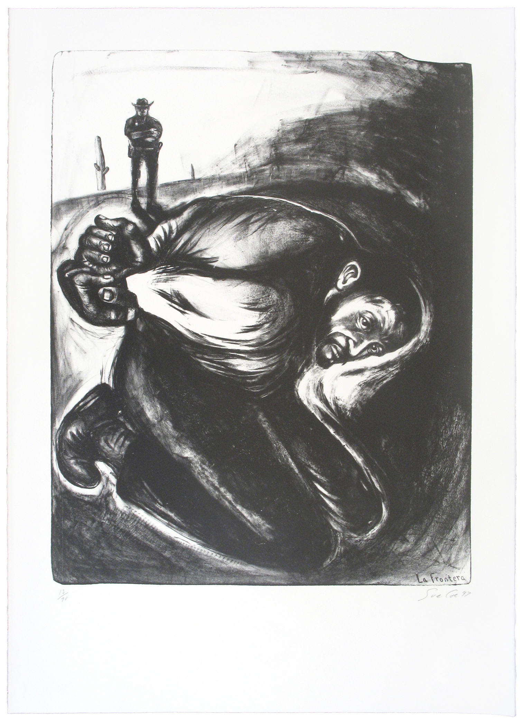

**Photo Caption:** Sue Coe (American b. 1951*), La Frontera*, 1997, lithograph, 36.5 x 26.5 inches. Segura Arts Studio.

For additional images, contact Gina Costa at [gcosta@nd.edu](mailto:gcosta@nd.edu) or 574-631-4720.

**The Snite Museum of Art, University of Notre Dame**

The Snite Museum of Art is located on the campus of the University of Notre Dame, near South Bend, Indiana. Museum hours are Tuesday through Friday, 10:00 a.m.–5:00 p.m.; and Saturdays and Sundays Noon–5:00 p.m. Admission is free. Museum information is available at 574-631-5466 or at the Museum’s website: <sniteartmuseum.nd.edu>. Driving directions and parking information are available at <http://nd.edu/visitors/directions/>. Find us at facebook.com.

The Snite Museum of Art provides opportunities to enjoy, respond to, learn from, and be inspired by original works of art. As a department of the University of Notre Dame, the Museum supports teaching and research; creates and shares knowledge, celebrates diversity through the visual arts, serves the local community, and explores spiritual dimensions of art.

**END**

**550words**