**Macintosh HD:Users:csnay:Desktop:Logos:snite logo black.pdf**

## Media Contact

Gina Costa

Phone: 574-631-4720

Fax: 574-631-8501

PO Box 368

University of Notre Dame

Notre Dame, IN 46556

gcosta@nd.edu

*University of* NOTRE DAME

**FOR IMMEDIATE RELEASE**

**Rembrandt Redux at the Snite Museum**

*Rembrandt’s Religious Prints: The Feddersen Collection at the Snite Museum of Art*

On view September 3–November 26, 2017

**Notre Dame, IN – May 1, 2017** – The Jack and Alfrieda Feddersen Collection of Rembrandt prints will make an encore appearance at the Snite Museum of Art September 3 through November 25. The exhibition of the renowned artist’s prints marks the publication of the first comprehensive catalog of the entire collection and the celebration of the University of Notre Dame’s 175th anniversary.

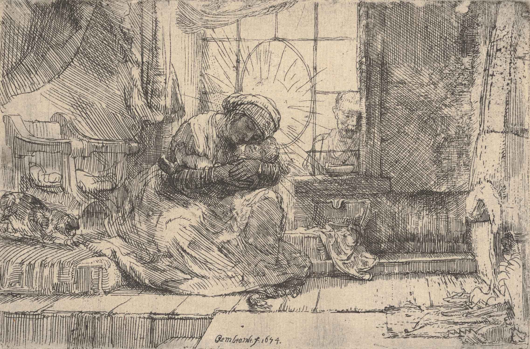All 70 of Rembrandt’s etchings that comprise the Feddersen Collection will be displayed together, examining the sweep of historical, theological, and artistic impulses that informed the creation of the master’s religious and biblical prints. From Jacob’s anguish resulting from the betrayal of his children to the joyous epiphany of the coming of the Messiah and the depths of despair at the entombment, Rembrandt plumbed the range of human experience and faith through keen observational skills and a supreme mastery of technique. His depictions of intimate family scenes and profound psychological engagement still resonate with visitors today.

Prints by other old master artists, such as Albrecht Dürer and Lucas van Leyden, which have been recently added to the Snite Museum’s holdings, will be included to illustrate Rembrandt’s development as an artist and to highlight the contributions he made to the art and philosophy of his time.

Jack and Alfrieda Feddersen, collectors from Elkhart, first loaned their prints to the Snite Museum in 1981 shortly after the new building on the University’s campus opened. Wanting their collection to be studied and enjoyed by students, faculty, and the local community, the Feddersens donated their collection to the Snite Museum in 1991. The prints have been used by classes and exhibited to the public ever since then.

“Exhibitions of our Rembrandt prints have long been a favorite in our community, and we are delighted to give the collectors and the artist their due on the 175th anniversary of the University’s founding,” said Charles Loving, director of the Snite Museum.

Charles M. Rosenberg, professor emeritus of art history at the University of Notre Dame, wrote the insightful and lavishly illustrated catalog, telling the story of how the collection was formed and offering extensive analysis and interpretation of each of the prints in view of the religious turmoil prevalent in the Netherlands in the 1600s. Considering John Calvin’s sermons, the writings of contemporary rabbis, and Catholic Counter-Reformation teachings, Rosenberg sheds new light on Rembrandt’s provocative art.

**Caption:** Rembrandt (Dutch, 1606­–1669), *Virgin and Child with the Cat and the Snake*, 1654, etching, 3.74 x 5.71 inches. Snite Museum of Art: Gift of Mr. and Mrs. Jack F. Feddersen, 1991.025.034 [For additional images, contact gcosta@nd.edu.]

**Catalog:** *Rembrandt’s Religious Prints: The Feddersen Collection at the Snite Museum of Art*, co-published by the Snite Museum of Art and Indiana University Press, 2017. 496 pages; 243 color illustrations; $70 retail. For details, visit http://www.iupress.indiana.edu/product_info.php?products_id=808362

**Programs:** Lecture: Larry Silver, Farquhar Professor of Art History at the University of Pennsylvania, “Rembrandt and the Divine,” September 14, 5 p.m. Annenberg Auditorium.

Fall Reception: September 15, 5–7:30 p.m. with remarks by Charles Rosenberg, Professor Emeritus of Art History, University of Notre Dame.

Saturday Scholar Series: Charles Rosenberg, Professor Emeritus of Art History, University of Notre Dame, “Intimate Objects of Beauty and Faith: The Feddersen Collection of Rembrandt’s Religious Prints,” October 28, time TBD, Annenberg Auditorium.

ALL PROGRAMS ARE FREE AND OPEN TO THE PUBLIC.

**The Snite Museum of Art, University of Notre Dame**

The Snite Museum of Art is located on the campus of the University of Notre Dame, near South Bend, Indiana. Museum hours are 10:00 a.m.–5:00 p.m., Tuesday through Friday; and noon–5:00 p.m. Saturday and Sunday. Admission is free. Museum information is available at 574-631-5466 or at the Museum’s website: sniteartmuseum.nd.edu. Driving directions and parking information are available at <http://nd.edu/visitors/directions/>. Find us at inthebend.com and facebook.com.

The Snite Museum of Art provides opportunities to enjoy, respond to, learn from, and be inspired by original works of art. As a department of the University of Notre Dame, the museum supports teaching and research, creates and shares knowledge, celebrates diversity through the visual arts, serves the local community and explores spiritual dimensions of art.

**323 Words**

**###**